**User Guide for NAO Kinect**

By: Jill Mercer and Brady Rainey

Group 3

**I – Setup**:

To run the Kinect Tracking program the computer must have:

1. Kinect for Windows SDK installed. (1.8 for Kinect 1.0, 2.0 for Kinect 2.0.)
2. A Kinect plugged into the computer.
3. On a network with at least one NAO robot.

This guide will help you set up these prerequisites and then get the program up and running.

**II – Installing Kinect SDK:**

1. Navigate to <https://developer.microsoft.com/en-us/windows/kinect> using a web browser.
2. Based on your Kinect, pick version 1.8 or version 2.0.
3. Follow the installation guide for your version.

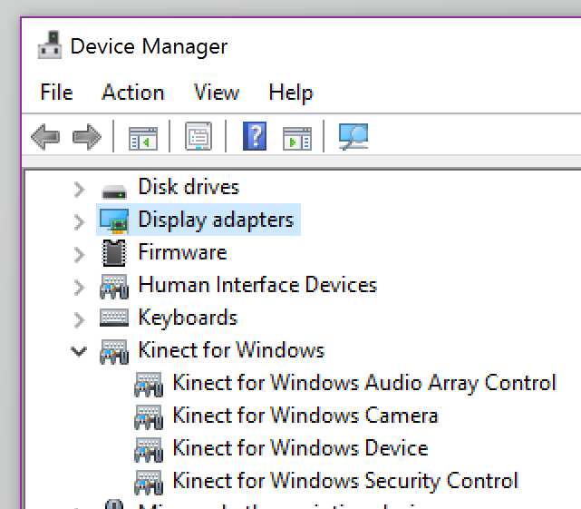

**III – Connecting Kinect to PC:**

1. Plug Kinect power into wall.
2. Plug Kinect USB into the PC.
3. Go to the Start Menu and type in “Device Manager”.
4. Look for “Kinect for Windows”.
5. Kinect is successfully installed.
6. Test by running “Run_KinectViewerDemo” in  
   the Kinect Tester folder.

**IV – Connecting NAO to Your Network:**

**Wired:**

1. Remove the plate from the back of NAO’s head.
2. Connect an Ethernet cable into the Ethernet port located under this plate.
3. Locate your internet router and connect the other end to a free port.
4. Power on NAO and it will connect automatically to your network.

**V - Running the Program:**

1. Once setup is complete, launch the NAO program.
2. Connect to a NAO by clicking File ➡ Connect and then Select All once connected NAOs are found.
3. Select a NAO and then click Run ➡ Kinect Tracking to launch the Kinect Viewer.
4. Make sure Kinect has found a skeleton. This is shown by a red stick figure overlay on a person in the Kinect Viewer.
5. Once a skeleton is present, the front button on the NAO’s head will begin mirroring. NAO will confirm verbally when mirroring has started.

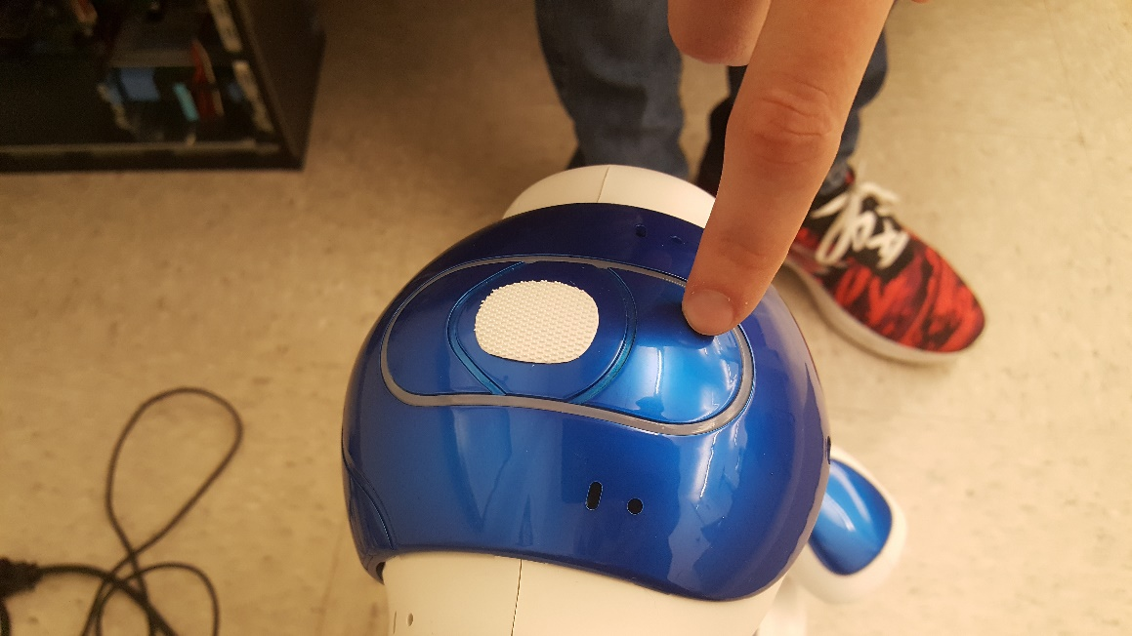

1. The button on the back of the NAO’s head will end mirroring.

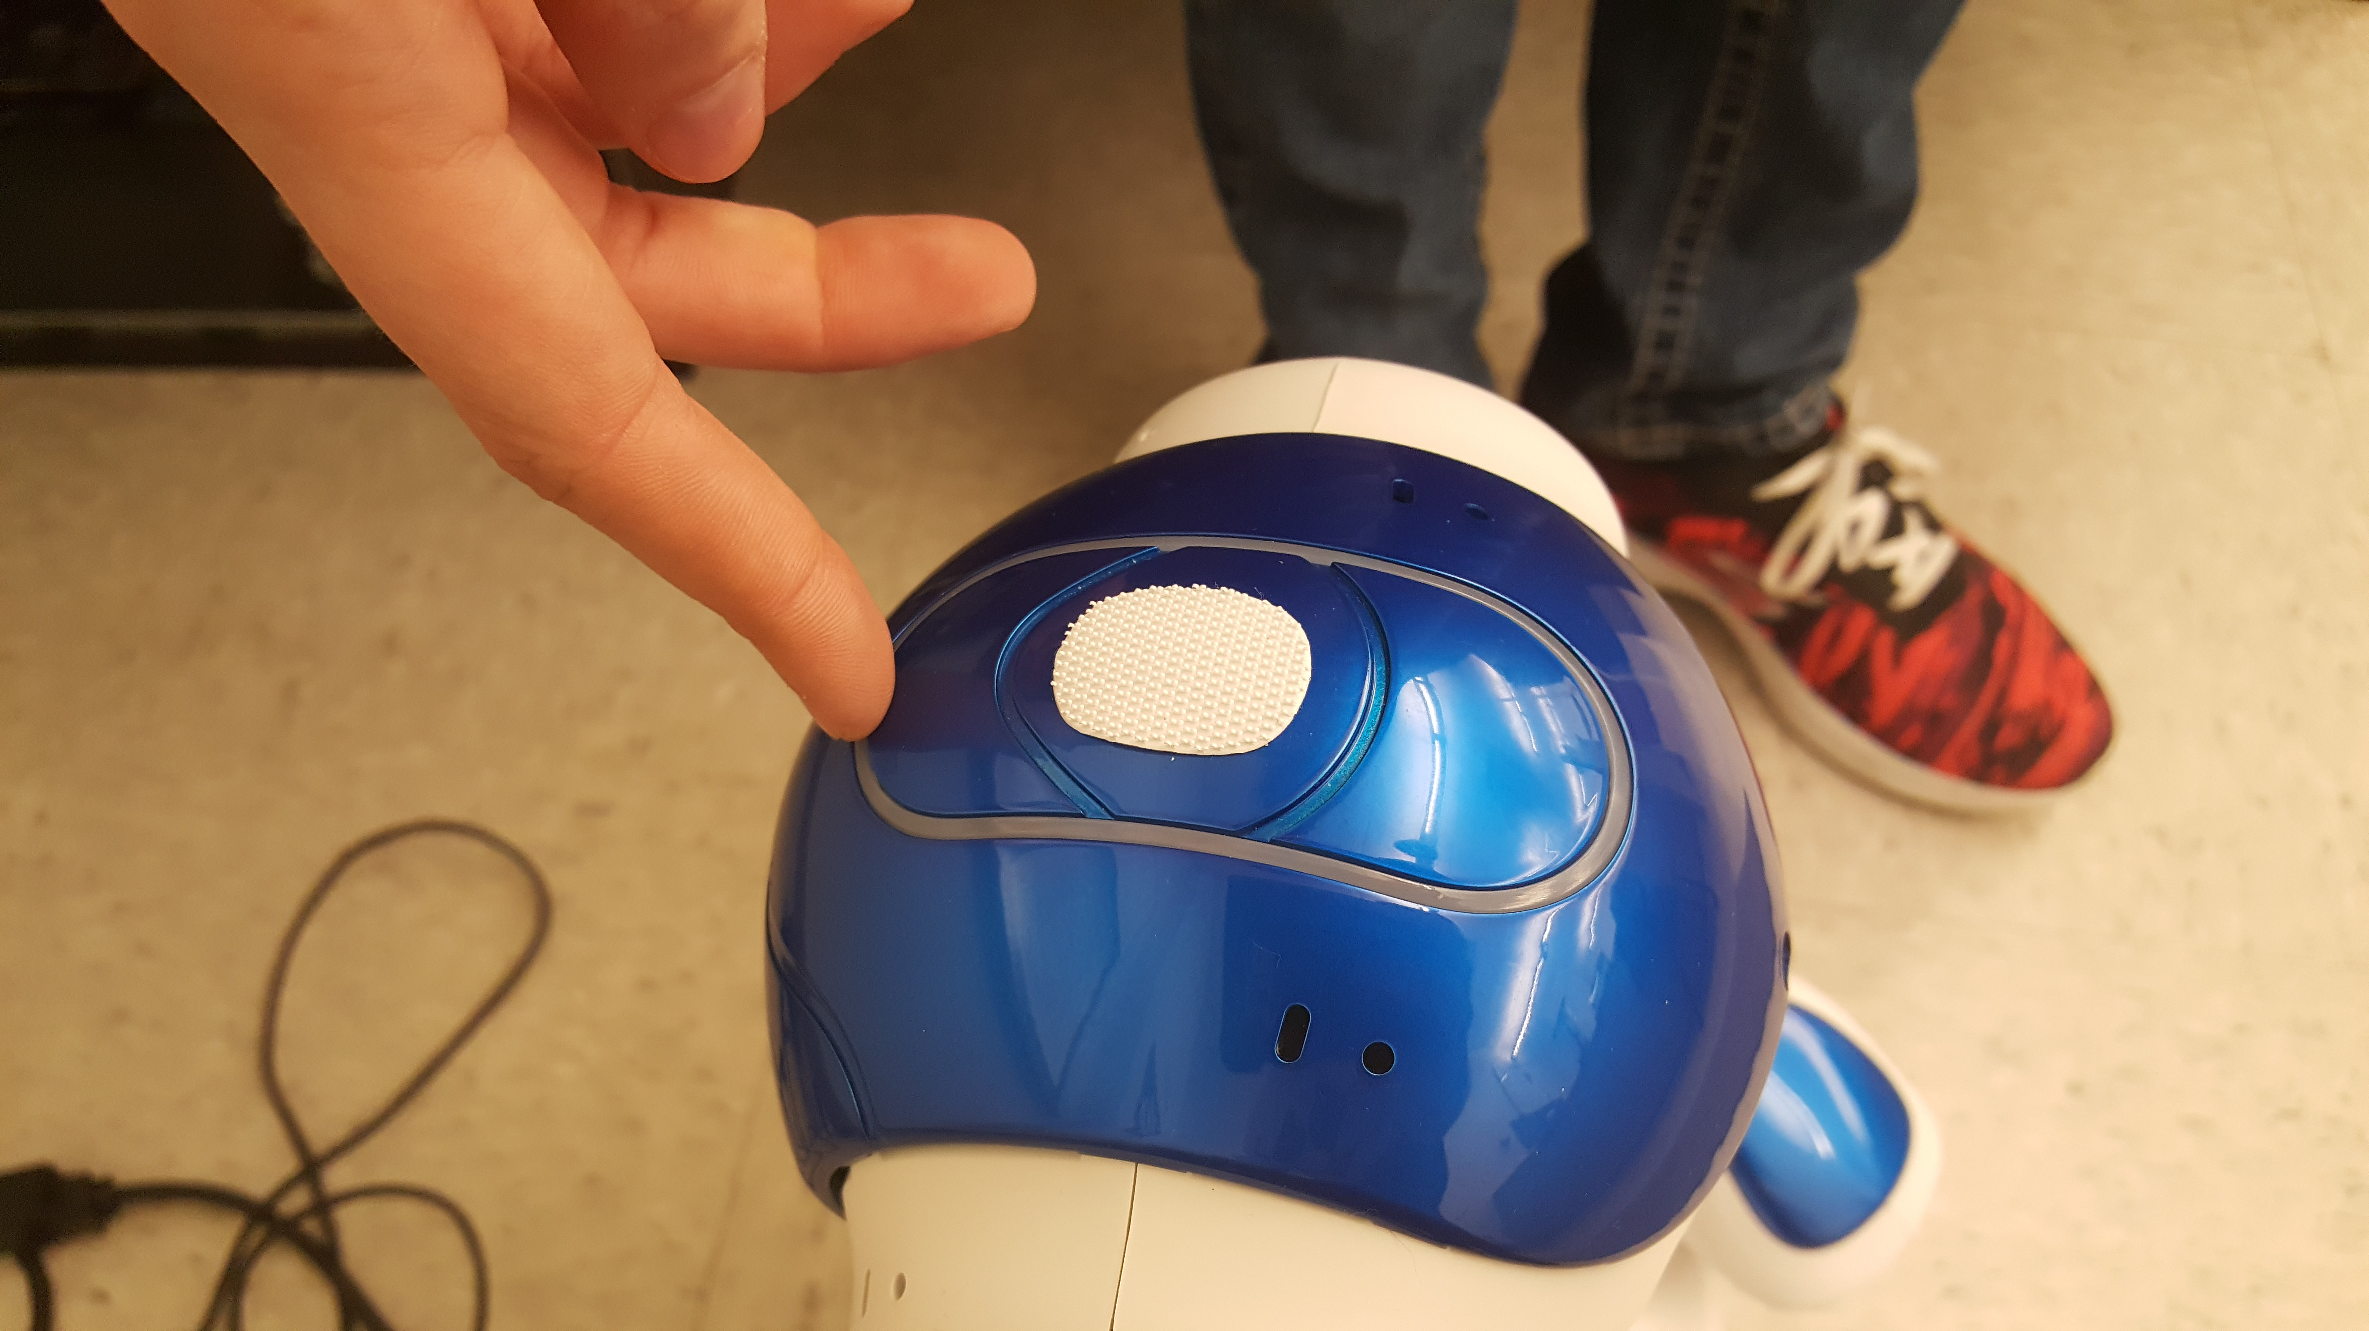

**VI – Kinect GUI Options:**

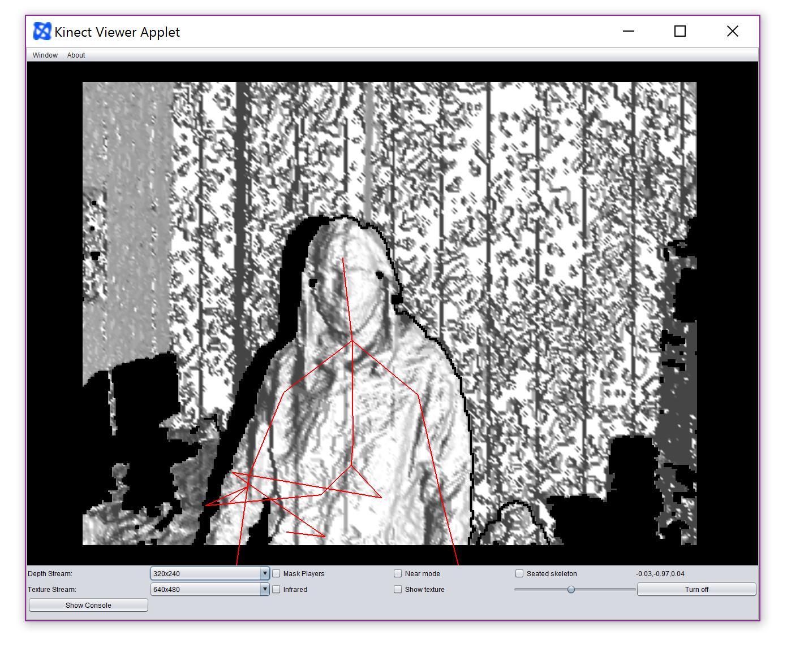

1. Depth Stream
   1. Resolution of depth mapping input.
2. Mask Players
   1. Strips out background.
3. Near Mode
   1. Changes calculations for closer objects.
4. Seated Skeleton
   1. Only pulls upper torso of skeletons.
5. Texture Stream
   1. Resolution of textured input.
6. Infrared
   1. Show’s input from Kinect’s infrared camera.
7. Show Texture
   1. Shows color input from Kinect. (Default is the depth mapping.)
8. Angle Slider
   1. Adjust angle of Kinect. Kinect will angle itself after adjustment.
9. Turn Off
   1. Turn Off Kinect.